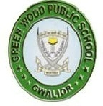
GREENWOOD PUBLIC SCHOOL, ADITYAPURAM
OUR MOTTO - DEVELOPMENT WITH DELIGHT
SYLLABUS FOR THE MONTH OF DECEMBER 2017-18
CLASS-NURSERY
SUBJECTS |  | ACTIVITY+USE OF ICT | PARENTS INVOLVEMENT
English | Oral : Rhymes- I am special, Engine-Engine….., Chubby Cheeks.  Written : Alphabets S-Z  Recog –Alphabets A-Z | 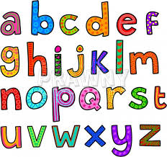 | Help your child in learning rhymes and written work
Hindi | Oral : dfork,¡ &रेल ] सीखेंगे हम ] चंदा मामा  Written : अक्षर & vkS ] va ] v%  Recog : अक्षर – v ] v% rd | 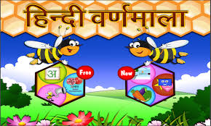 | dfork,sa ;kn djok,Wa rFkk o.kksaZ dh igpku fp=ksa +}kjk djok,W!
Maths | Oral : Counting 1-40  Written :Digits 15-20 | 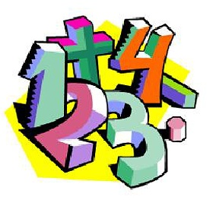 | Motivate your child in counting objects and learning tables.  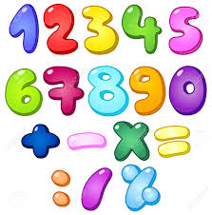
Drawing | Page no. 13-20
G.K. | Oral : Months name, Days of week, Body Parts . |  | Help your child to recog. the colours
Music / Dance | Jingle Bell/ Christmas Dance
V.E. | Be polite and be positive |  | Motivate your child to help others
Sports | Lemon race, frog race
Language Development | This is our school. |  | Help your child to develop good habits
Conversation | English Conversation  1.What is the name of our country?  Ans-India  2.What is the name of our state?  Ans-Madhya Pradesh  3.When do you celebrate Christmas ?  Ans-25th December.  4.How many seasons do we have?  Ans-four seasons.  5.Which month is running now?  Ans-December. | Hindi Conversation  प्रश्न 1- आपके देश का नाम क्या है ?  उत्तर - भारत  प्रश्न 2- आपके प्रदेश का नाम क्या है ?  उत्तर - मध्य प्रदेश  प्रश्न 3- हम क्रिसमस कब मानते है ?  उत्तर - 25 दिसम्बर  प्रश्न 4- ऋतुएँ कितने प्रकार की होती है ?  उत्तर - चार  प्रश्न 5- यह कौन सा महीना चल रहा है ?  उत्तर - दिसम्बर | Help your child in learning Conversation Que/Ans  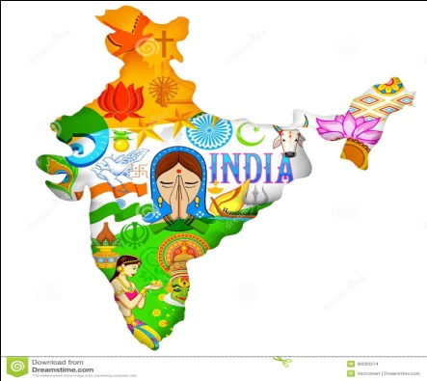

Activity Planner
Work Education  Health and Wellness  Performing Arts  Eco-club Activity | Origami(Christmas Tree)  Importance of cleanliness.  Festival song.  How to clean our table after lunch. | Literary and Creative | Telling 3 or4 lines about Myself.

